**Name: Parmita Patre**

**Class: Final Year CSE Div: B**

**Roll: B_58**

**Assignment 3**

Perform the following operations on Git and GitLab.

* Create a Repository/Project

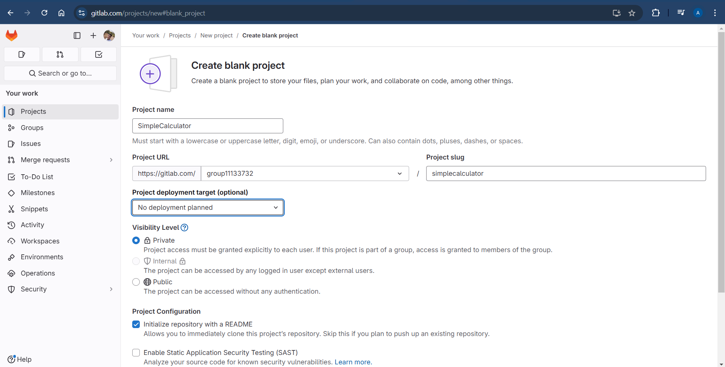

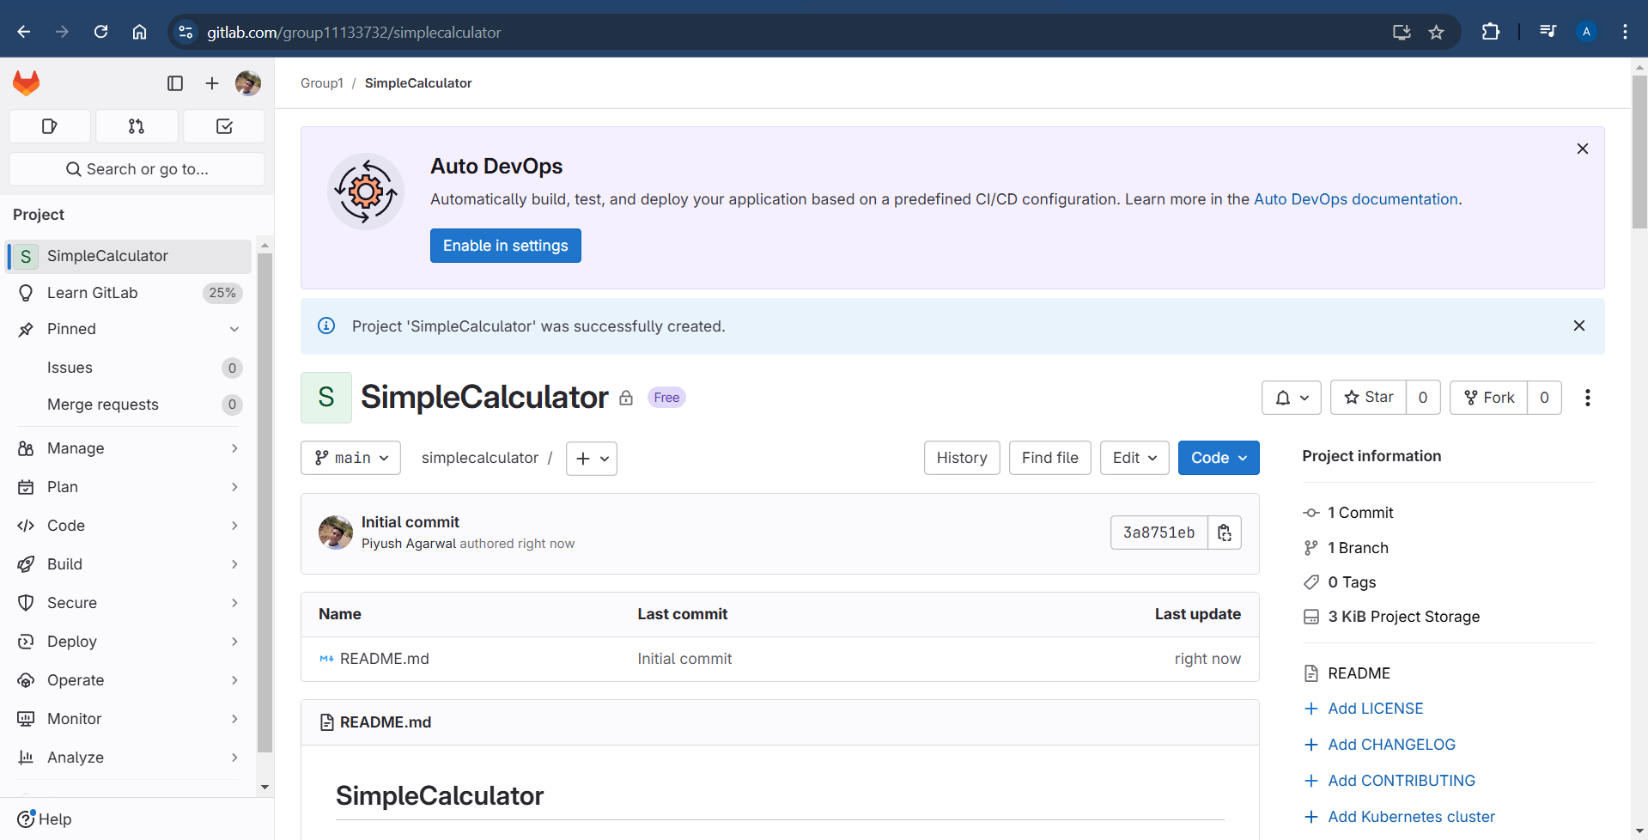

* Create Branches

git branch: Lists all local branches and highlights the current branch.

git branch secondBranch: Creates a new branch named secondBranch.

git checkout secondBranch: Switches to the branch named secondBranch.

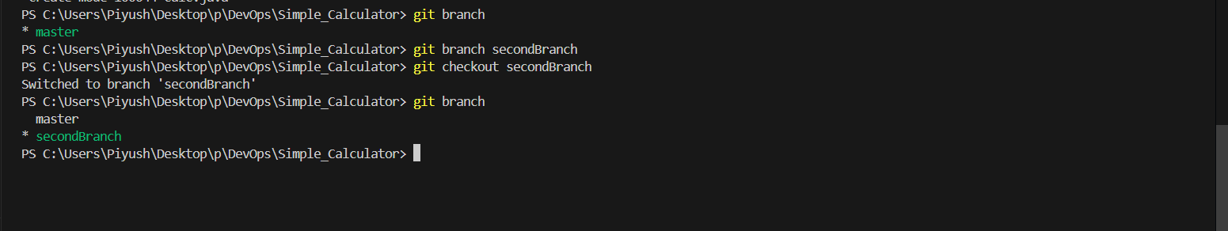

* Perform Add, Commit, Push, Pull

git add: Stages changes in the working directory for the next commit.

git commit -m: Records staged changes with a message describing the commit.

git push origin master: Pushes local commits to the master branch on the remote repository named origin.

git remote add origin <URL>: Adds a remote repository named origin with the specified URL, allowing you to push and pull from it.

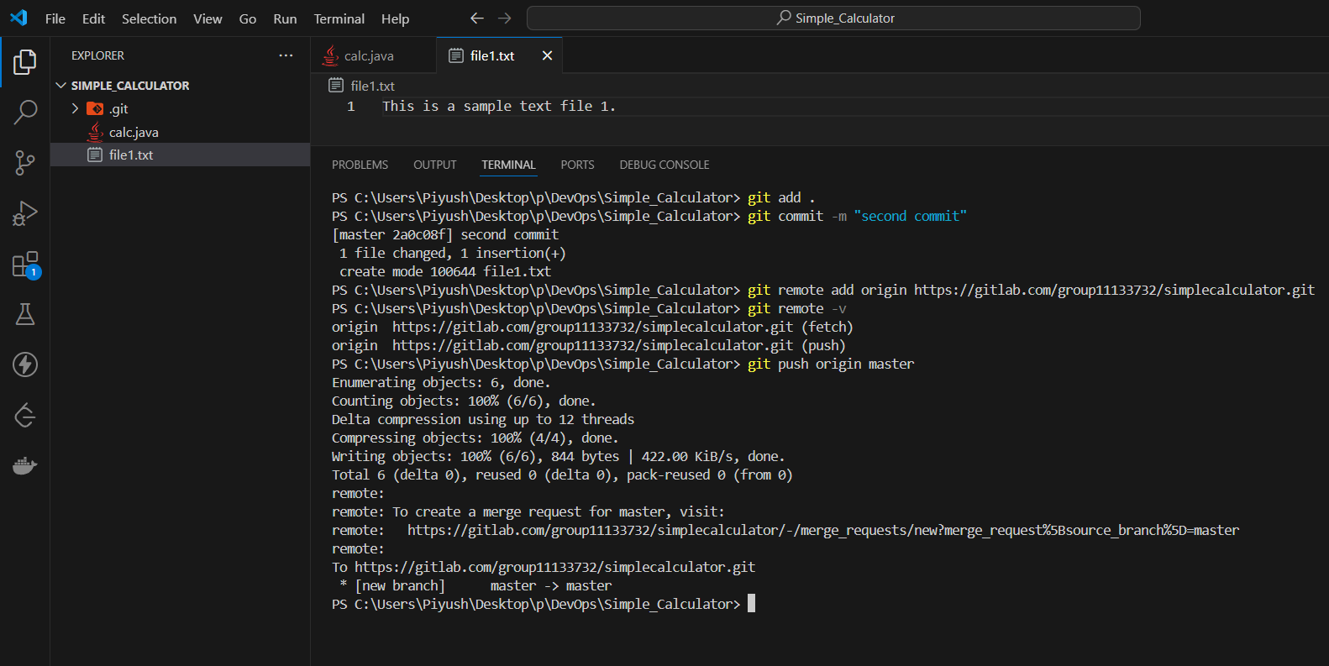

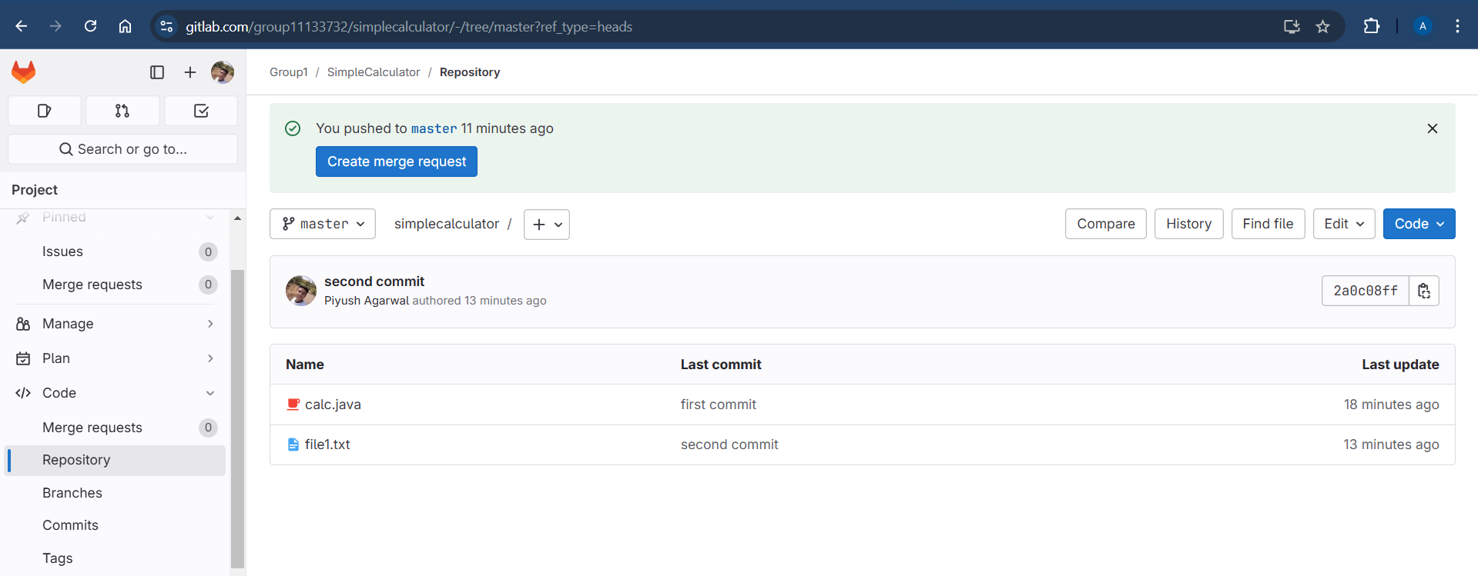

git pull origin master: Fetches and merges changes from the master branch on the remote repository origin into the current branch.

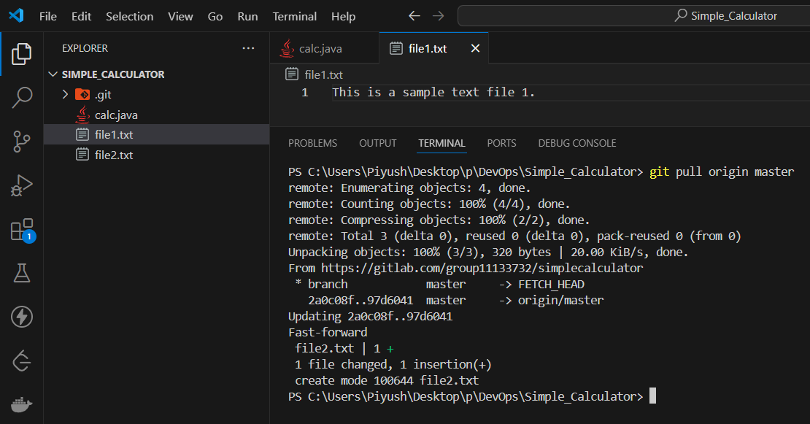

* Undo commits

git log --oneline: Shows a compact list of commits with a one-line summary for each commit.

git reset --hard HEAD~1: Moves the current branch back by one commit and discards all changes in the working directory and staging area.

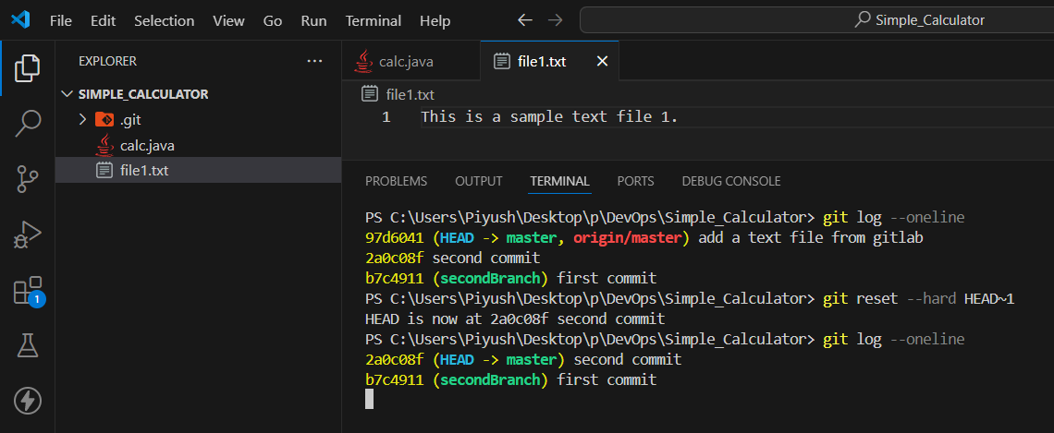

* Fork a project, Open and merge Pull request

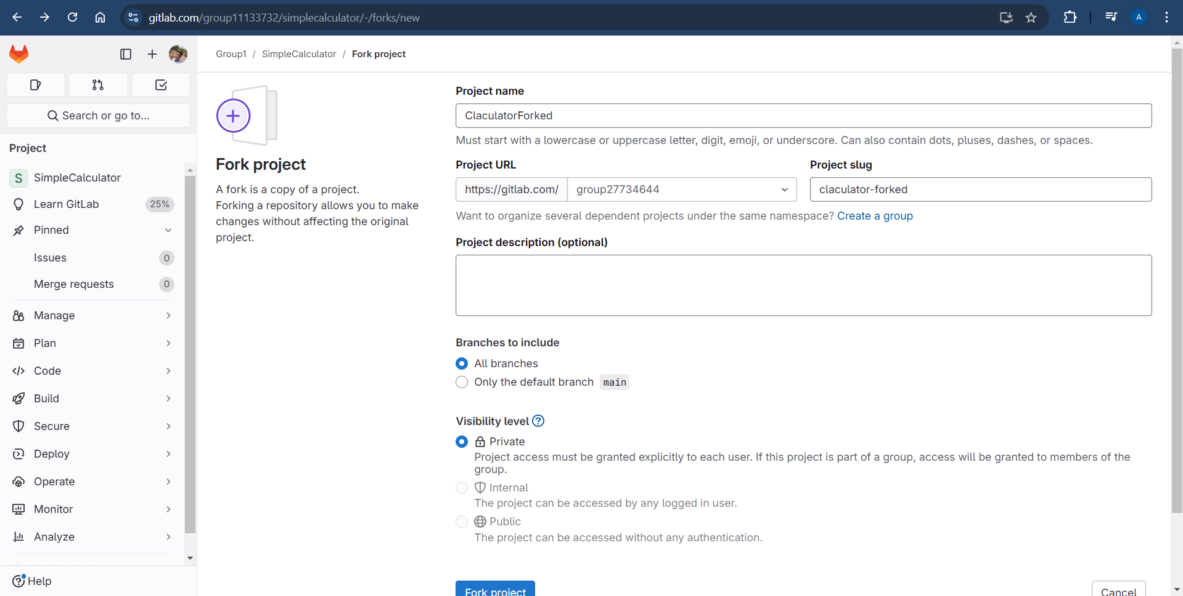

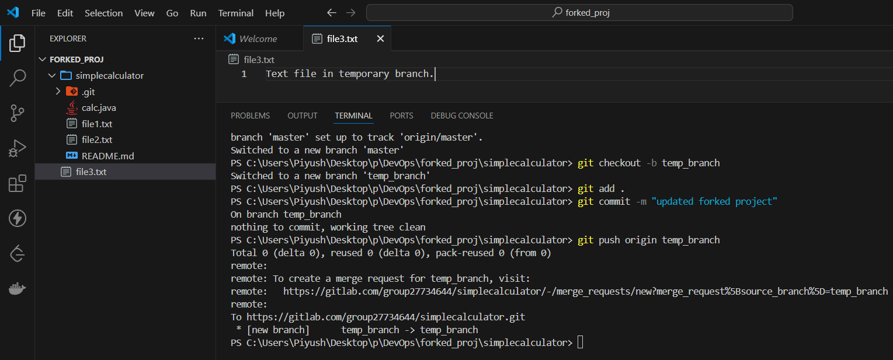

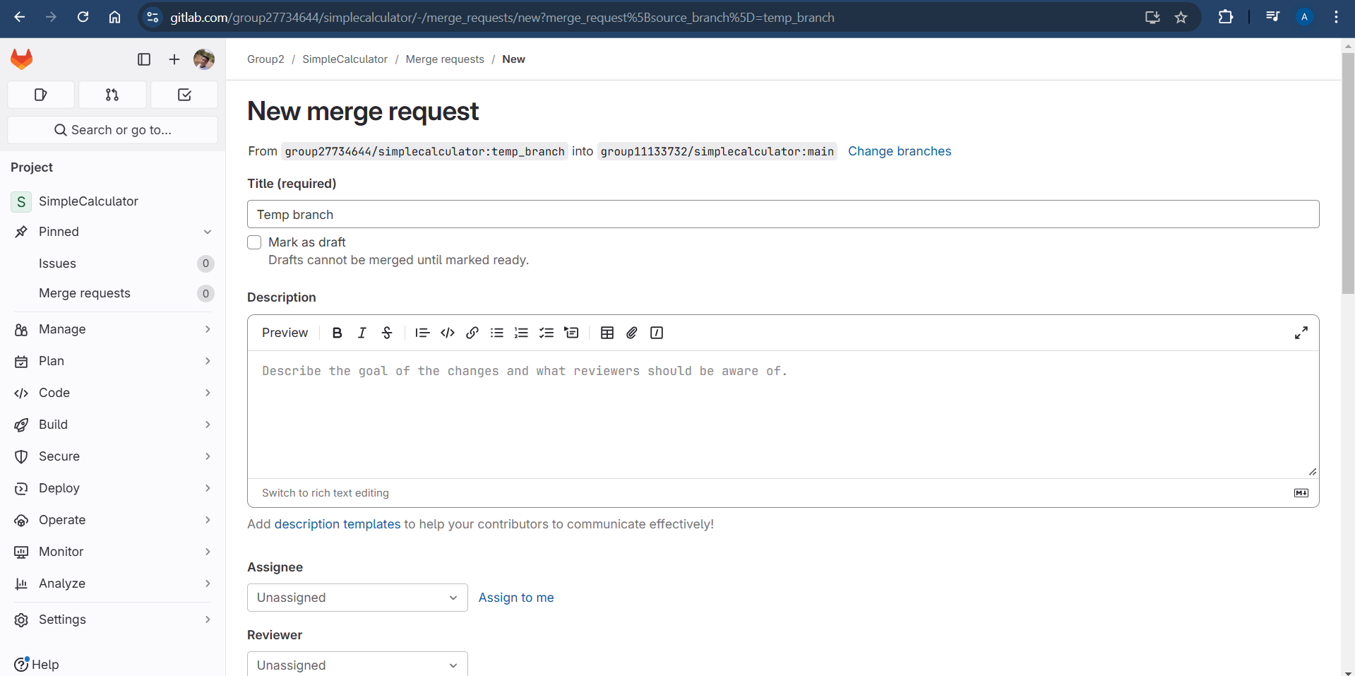

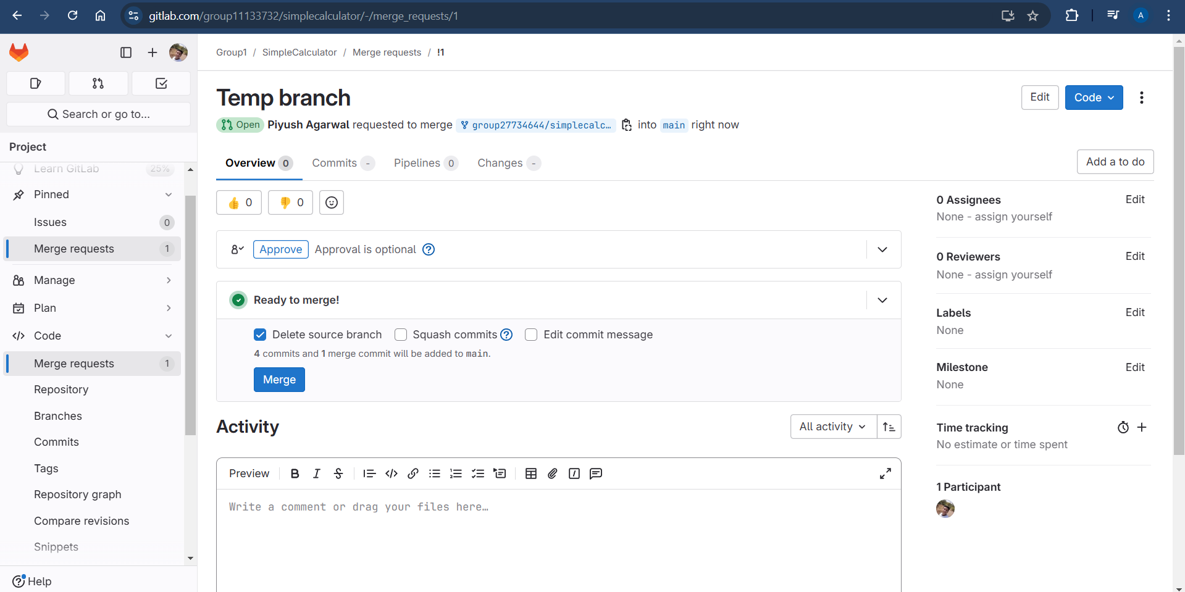

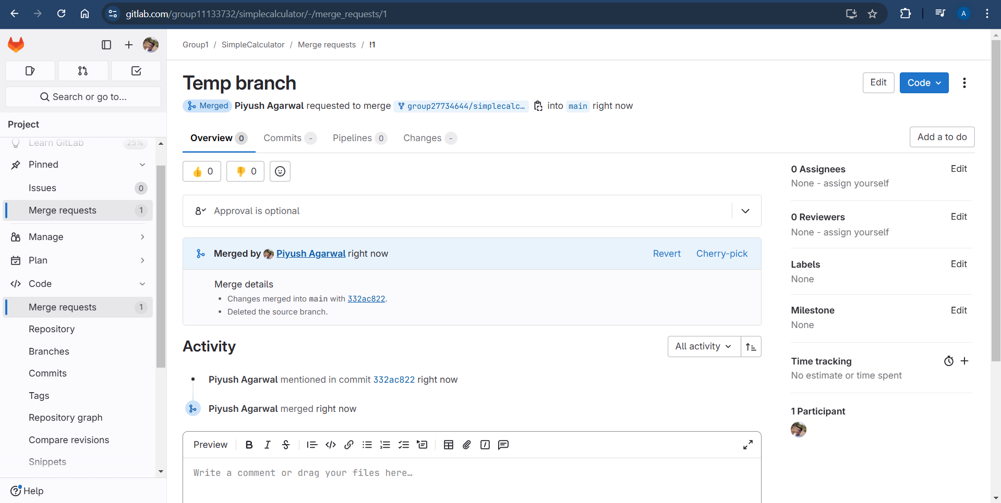

* Merge and Rebase

git merge: Combines changes from one branch into another, creating a new merge commit to reflect the integration.

git rebase: Reapplies commits from one branch onto another, effectively moving the base of the branch to a new commit and creating a linear project history.

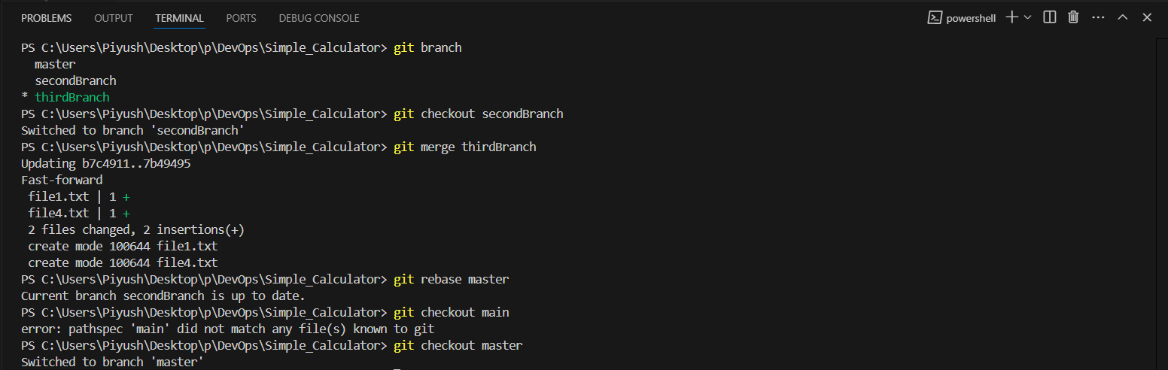

* Squashing Commits

git rebase -i HEAD~n: Opens an interactive rebase editor for the last n commits, allowing you to edit, reorder, or squash commits.

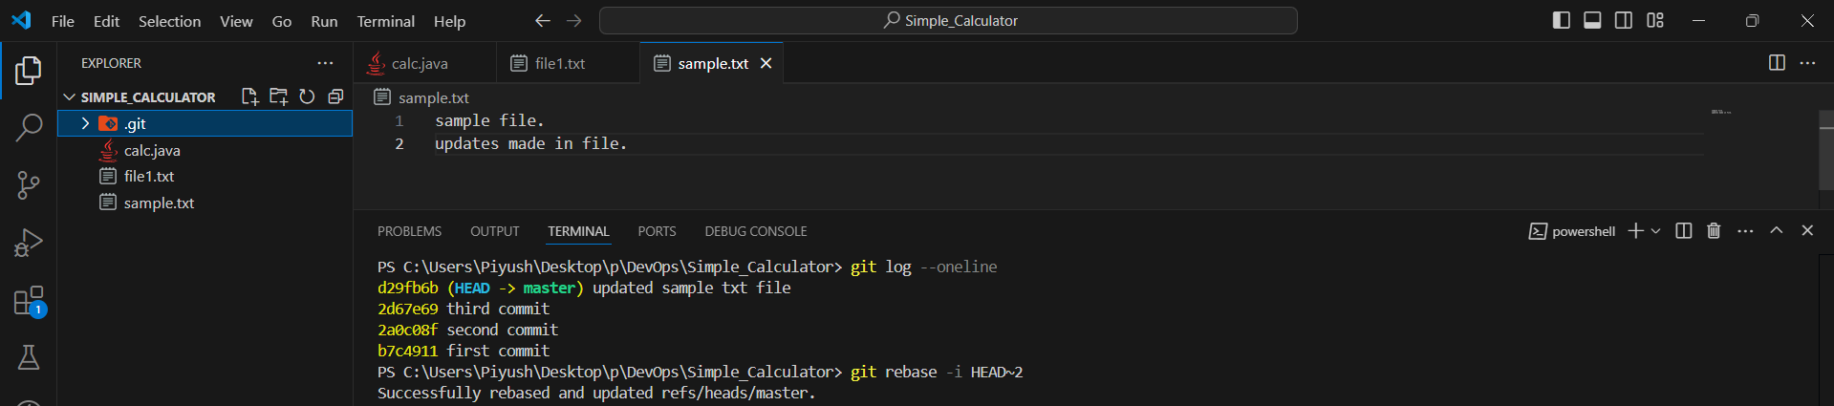

* Delete local and remote branches

git branch -D <branch-name>: Deletes the specified branch locally, even if it hasn't been fully merged.

git push origin --delete <branch-name>: Deletes the specified branch from the remote repository named origin.

